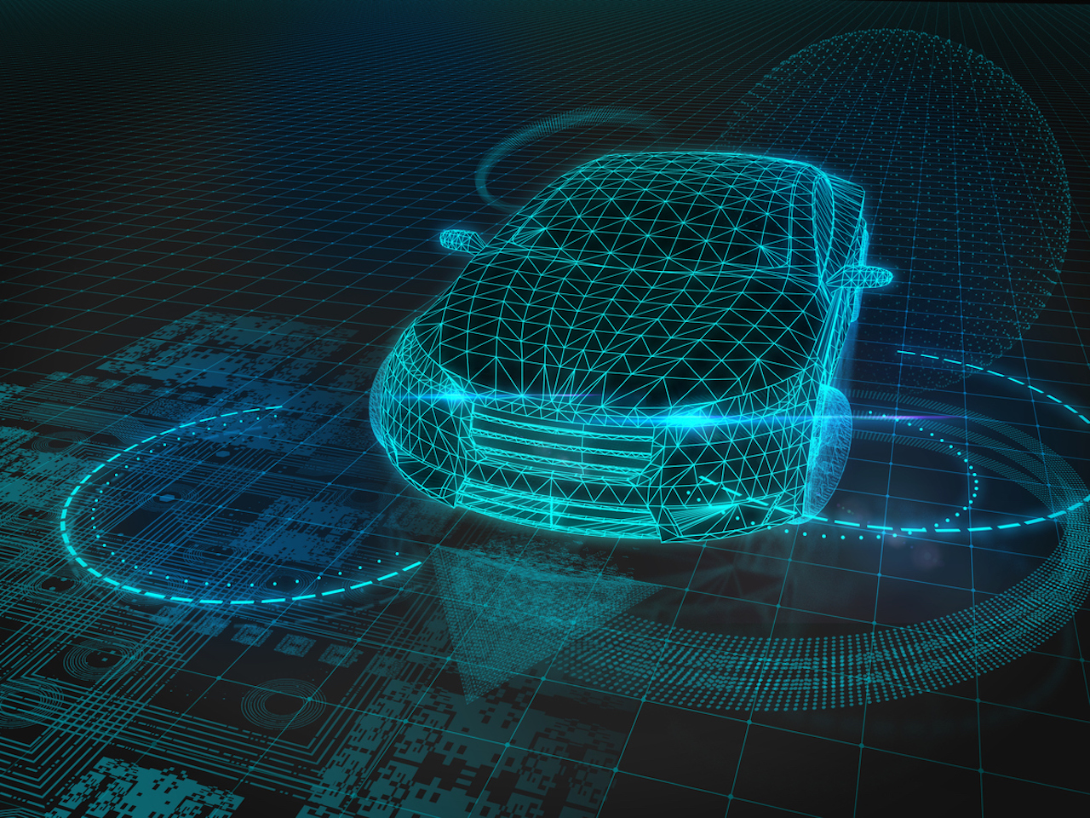

version 4.2

‏23/10/2021

SMART CITY TRASPORTATION

DyNAMIC TRANSPORTATION LAWS IN A SMART CITY

Project Code: 21220340

Preparing report – FINAL PROJECT 2022

ACADEMIC instractor 1: Ms. Sara tsor

ACADEMIC instractor 2: Mrs. yoram segal

presentors

student name 1: 312272230, saar elias

student name 2: 312389083, Naor yekutiely

instractors signiture

Table of content

1 Summary 2

2 introduction 3

2.1 How the project is related to a general field 3

2.2 defining the problem 3

2.3 The technological CHALLENGE 4

3 Ways to solve the problem 4

4 expected project artifact 5

5 Describing a similar idea that can be inspiring 5

6 Risks, uncertainty and project constraints 5

7 References 7

appendices list 8

Appendix A – block diagram 9

Appendix b – milestones and artifacts table 10

# Summary

In this project we present an innovative approach towards transportation solution in a futuristic smart city. With the rising of new technologies such as autonomous vehicles, 5G networks, and cloud computing the future of transportation within smart cities is expected to improve in many factors. In a futuristic smart city, when transportation will be autonomous and no human decision will take part, we present a new way of thinking about transportation and road infrastructure in general. All traffic laws will be digitalized and dynamic. These dramatic changes will open up new ways for optimizing traffic and using the road infrastructure in the most efficient way possible. This project Presents an architecture for such futuristic system as well as intuitive examples for how such system can be implemented. The full system will consist of two Autonomous Vehicles, small city model and a server. The vehicles and the server will have a continuous communication sending data back and forth. Every vehicle is fully independent and makes decisions based on his current position and the data he holds for this position. For example, the vehicle knows his in street X with traffic laws of Y, When Y is a finite set of traffic laws for street X. The server may change Y under certain conditions forcing the vehicles to act accordingly. In this project we do not aim to present a certain optimization technic but rather to show the possibility for such system existence in the future and encourage others to implement traffic optimization algorithms with this new futuristic approach.

# introduction

The general field of our project is Smart Cities. The rapid growth of human population, spoilage of natural resources, increasing population and number of vehicles in the urban life around the world are in a desperate need of a modern solution which the existing model of a city has we know it cannot provide. To solve these issues a new city model has been proposes in past several years know as a Smart City [1]. Also called eco-city or sustainable city, the smart city aims to improve the quality of urban services or reduce its costs. In the past few years many governments and cities around the world adopted this approach and implemented it in many different ways. Implementations and actions already taken in the field of Smart cities are adequate water supply, assured electricity supply, sanitation, including solid waste management, efficient urban mobility and public transport, affordable housing, robust IT connectivity and digitalization, good governance, sustainable environment, safety and security of citizens and more. Examples for such cities are Singapore, Barcelona, San Francisco, London and more. Building a smart city or transforming a city into one is no easy task, and there are many challenges to take into account. infrastructure and costs, security and privacy concerns and social risks are a partial list of the challenges in building a smart city. Despite these challenges a smart city has many practical, economic benefits such as environment impact, optimization of energy and water management, transportation, security and many more.

## How the project is related to a general field

One of the key aspects of A smart city is transportation. Due to investment in and development of road infrastructure and vehicle technology, autonomous vehicles are expected to be the next big breakthrough [2]. In the future, drivers will not be required to drive their vehicles, but instead the vehicle will be supplied with the destination's address, and the vehicles will begin to travel the required route using traffic laws visible on the road and connectivity to the Internet. A smart city transportation network needs to be clean and efficient. The main goal is Reducing traffic congestion inside the city as well as Reducing the CO2 footprint. In order to provide a city with Intelligent transportation there is a need of many sensors and traffic management centers. Technologies that are currently being developed in the area of autonomous vehicles (AV) are crucial part of transforming a city into a Smart City [3]. The project integrates with Smart city area with Autonomous vehicles and smart transportation systems. AV are already been used in many Smart Cities around the world [4]. Another way that this project interacts with smart cities is innovation. Smart cities relay on new technologies and innovative problem-solving thinking. In this project we present an innovative way for using the vast amount of the data that a smart city produces in a new transportation system that has yet been invented. The transportation system we propose is a futuristic system that assumes there are only AV’s on the road. The system will reexamine and update traffic laws in real time. We call it Dynamic transport law system (DTLS). The system will be capable of changing the rules of the road (under certain conditions) and updating the vehicles with these new rules in real time. The DTLS aim is to unless the real power in AV’s.

## defining the problem

In the past decade traffic congestions has become an inescapable condition in large and growing metropolitan areas across the world [5]. Traffic congestions are getting worst with the growth of human population and increasing ratio of human–vehicle. The current traffic architecture and systems cannot handle the number of vehicles on the road and a new solution for inner city transportation is required.

## The technological CHALLENGE

There are couple of reasons that a system such as DTLS has not yet been invented, The DTLS is a futuristic system that cannot be implemented without some core futuristic dependencies such as all vehicles will be fully automated with no exceptions, Wide spread of 5G networks all around the city, Social and government conception and more. No such city exists yet and, in this project, we will simulate such futuristic city. The growth of AV industry, 5G networks, Cloud computing and efficient hardware technologies enables the DTLS possible existence. For example, in this project we are using NVIDIA Jetson Nano is a small, powerful computer that lets you run multiple neural networks in parallel for applications like image classification, object detection, segmentation, and speech processing. Assuming the DTLS exists and up and running in a smart city, transport congestions will be nearly eliminated within this city. The reason that DTLS can make such a difference is a new innovative way of thinking about road infrastructures. Imagine a major highway leading in and out of the city on a Monday morning, one side of the road for entering the city is highly conject and the other way is almost completely empty as shown in Figure 1. It is clear that this not an optimized way of using road infrastructures. In such situation the DTLS will open both way in the direction of entering the city and use alternative ways for leaving the city.

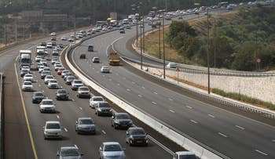

Figure 1: one way traffic congestion

# Ways to solve the problem

Our primary objective is to solve the problem by simulating the travel of two autonomous vehicles that report their location and state to the server and with the help of the DTLS will determine new traffic laws and traffic maps in real-time.

The solution of our project consists of two major parts:

1. Two autonomous vehicles:
   1. Hardware: The vehicles are equipped with Arduino-based self-driving systems, as well as Jetson-based case and response systems. The Arduino will control driving related hardware such as motors. And the Jetson will control all the machine learning related hardware such as camera, Lidar, etc.
   2. Software: The Arduino micro-controller will be loaded with routine software to control all the hardware related to driving. This software will be written in C language using the Arduino IDE. The Jetson nano will be loaded with Ubuntu OS which will run the ML related software using Python language and additional ML frameworks such as TensorFlow. In addition, the Jetson nano will hold the current map and traffic laws and feed them to the Arduino. The Jetson will communicate with the main server using WIFI sending data about congestions and obstacles and receiving updated map and traffic laws from the server. whenever a new map or laws update is received by the Jetson it will pass it on to the Arduino.
2. DTLS (Dynamic transport law system) software and infrastructure:
   1. Hardware: The main server will be a personal computer with Ubuntu OS. The main server will not require special computing power for this project and thus it can be any personal use computer. The minimal requirements from the server are having WIFI communication abilities.
   2. Software: The DTLS will run on the main server. Receiving data from the vehicles analyzing it and making map and laws decision and sending those decisions in the form of a new updated map and a set of traffic laws. All data transformation will be passed using JSON format.

Our approach for implementing the transportation in a smart city is innovative and futuristic. A smart city transportation using AV provides us with new solutions and opportunities [6].

# expected project artifact

In the end, we expect to show the ability of creating dynamic traffic law system in a smart city by presetting a number of real-life situations where the DTLS can be evolutionary. We will present a simple map with a few destination points and two AVs driving on the map. The AVs will purposely create a number of situations such as collisions and traffic congestions and report them to the server. The server will analyze the data, and send new traffic laws to the AVs. The AVs will react to these new laws in real-time and show the innovative solution that the DTLS offers in an intuitive way. To show the chain of events the server will be connected to an external monitor showing the current status of traffic laws in real-time.

# Describing a similar idea that can be inspiring

Every Monday morning while driving to work in Tel-Aviv, we have a lot of free time for thinking while almost standing still in traffic jams on Ayalon high-way. Every time we look to the other side of the road leading outwards from the city an uneasy feeling is passed throw our body when seeing it almost completely empty. One morning we understood why. Seeing such inefficient and waste of road infrastructure, suddenly didn’t make sense. These thoughts with the combination of prior knowledge of the concept of smart cities led us to this idea.

# Risks, uncertainty and project constraints

This project requires integration of many different technologies including hardware and software aspects. As result there are many risks involved as follows:

1. Autonomous Vehicles:
   1. Risk: working with many hardware components that we are not familiar with.
   2. Possible solution: choosing popular components that have a good documentation or components that our instructors suggest or familiar with.
   3. Risk: Depending on many hardware components.
   4. Possible solution: In the worst scenario we won’t be able to receive all the required hardware for the Autonomous Vehicles. We can use simulations of the Vehicles or modify an existing vehicle from a different project and modifying it to our needs.
   5. Risk: Determine the exact position of a vehicle in a small resolution.
   6. Possible solution: using barcode scanners to “checkpoint” the vehicle positions.
2. Prior Knowledge:
   1. Risk: The AVs requires practical knowledge in machine learning.
   2. Possible solution: Learning ML from our instructors and from online courses.
   3. Risk: This project requires a Real-time application with very small response time.
   4. Possible solution: working with powerful hardware and writing efficient code.
3. Innovation:
   1. Risk: The DTLS is innovative and thus we have no prior attempts to learn from. This may lead to unexpected issues along the way.
   2. Possible solution: stay in a can-do mind set, thinking out of the box and working hard.

# References

|  |  |
| --- | --- |
| [1] | N. Radovan, K. Radek and K. Jaroslav, "Smart City Concept, Applications and Services," *Journal of Telecommunications,* vol. 3, p. 8, 2014. |
| [2] | A. Faisal, T. Yigitcanlar, M. Kamruzzaman and G. Currie, "Understanding autonomous vehicles," *Journal of Transport and Land Use,* vol. 12, pp. 45-72, 2019. |
| [3] | T. Campisi, A. Severino, M. Ahmad Al-Rashid and G. Pau, "The Development of the Smart Cities in the Connected and Autonomous Vehicles (CAVs) Era," *Infrastructures,* vol. 6, p. 21, 2021. |
| [4] | B. Macy , "techrepublic," 5 February 2020. [Online]. Available: https://www.techrepublic.com/article/autonomous-vehicles-how-7-countries-are-handling-the-regulatory-landscape/. [Accessed 5 February 2020]. |
| [5] | A. Downs, "brookings," 1 January 2004. [Online]. Available: https://www.brookings.edu/research/traffic-why-its-getting-worse-what-government-can-do/. [Accessed January 2004]. |
| [6] | S. Asadi Bagloee, M. Tavana, M. Asadi and O. Tracey, "Autonomous vehicles: challenges, opportunities, and future implications for transportation policies," *Journal of Modern Transportation,* vol. 24, pp. 284-303, 2016. |

appendice

# appendices list

**Appendix A – Block diagram**

**Appendix B – Milestone and artifacts table**

# Appendix A – block diagram

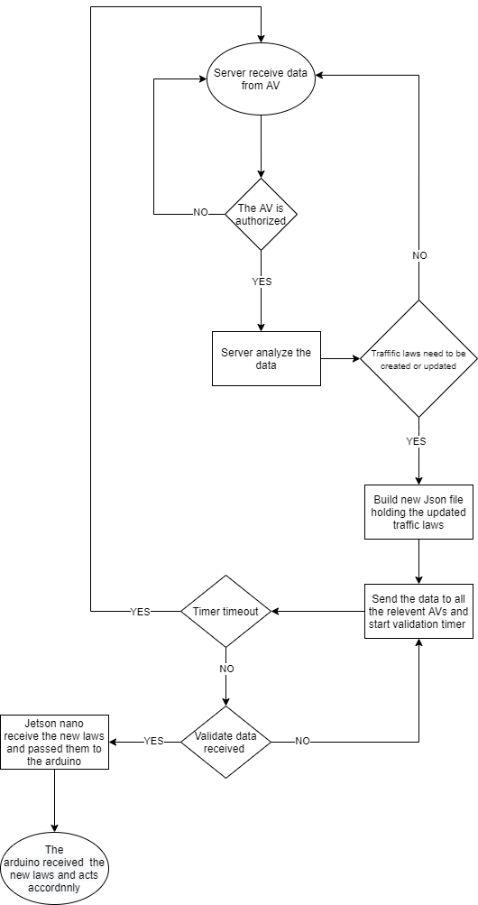

Figure 2: DTLS block diagram

# Appendix b – milestones and artifacts table

|  |  |  |  |  |
| --- | --- | --- | --- | --- |
| Artifact | Total man hours | End date | Milestone description | Milestone number |
| Preparing report | 25 | 24/10/2021 | Preparing report | 1 |
| Driving vehicles + running server | 140 | 4/1/2022 | Hardware validation | 2 |
| Progrerss report | 50 | 16/1/2022 | Progrerss report | 3 |
| AVs communicate with the server | 300 | 3/7/2022 | Vehicles and server integration | 4 |
| Poster + presenatation + POC | 60 | 12/7/2022 | Projects day + practical presentation | 5 |
| Completly operative system | 120 | 8/9/2022 | Final ajustments | 6 |
| Project book + working project | 45 | 15/9/2022 | Defanses | 7 |